11. ReactJS-HOL

**Solution:**

Step **1:** Setting up a react-app named “**evenetexampleapp**” using the command on vs code terminal:

[ npx create-react-app eventexampleapp]

Step **2**: **Implementing** the tasks written below, **in a single-file** in **App.js** :   
 a. Increment/Decrement counter button

b. Say-Welcome button

c. OnPress button

d. Currency Convertor

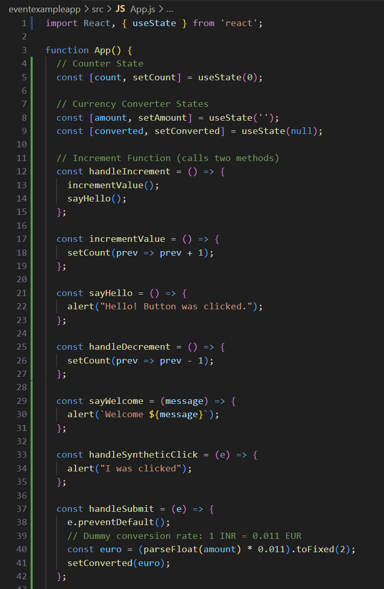

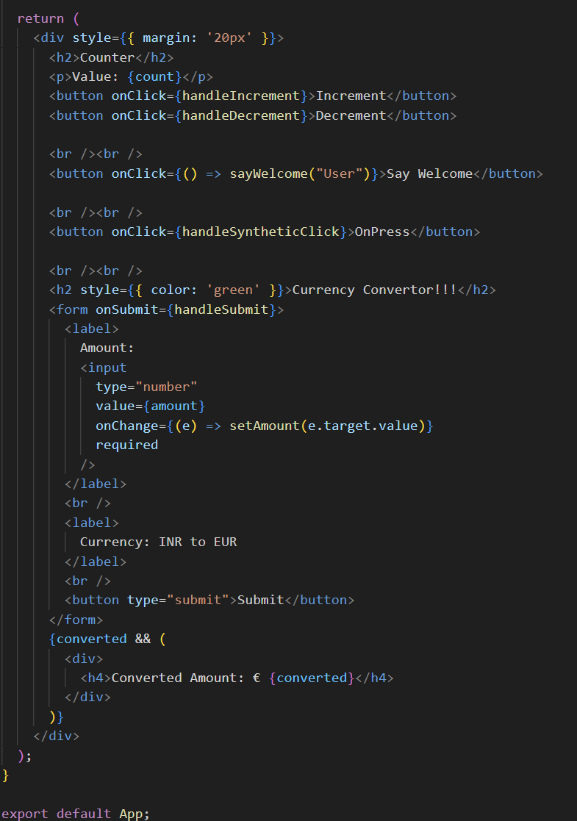

Step **3: Run** of the application 🡪 **npm start**

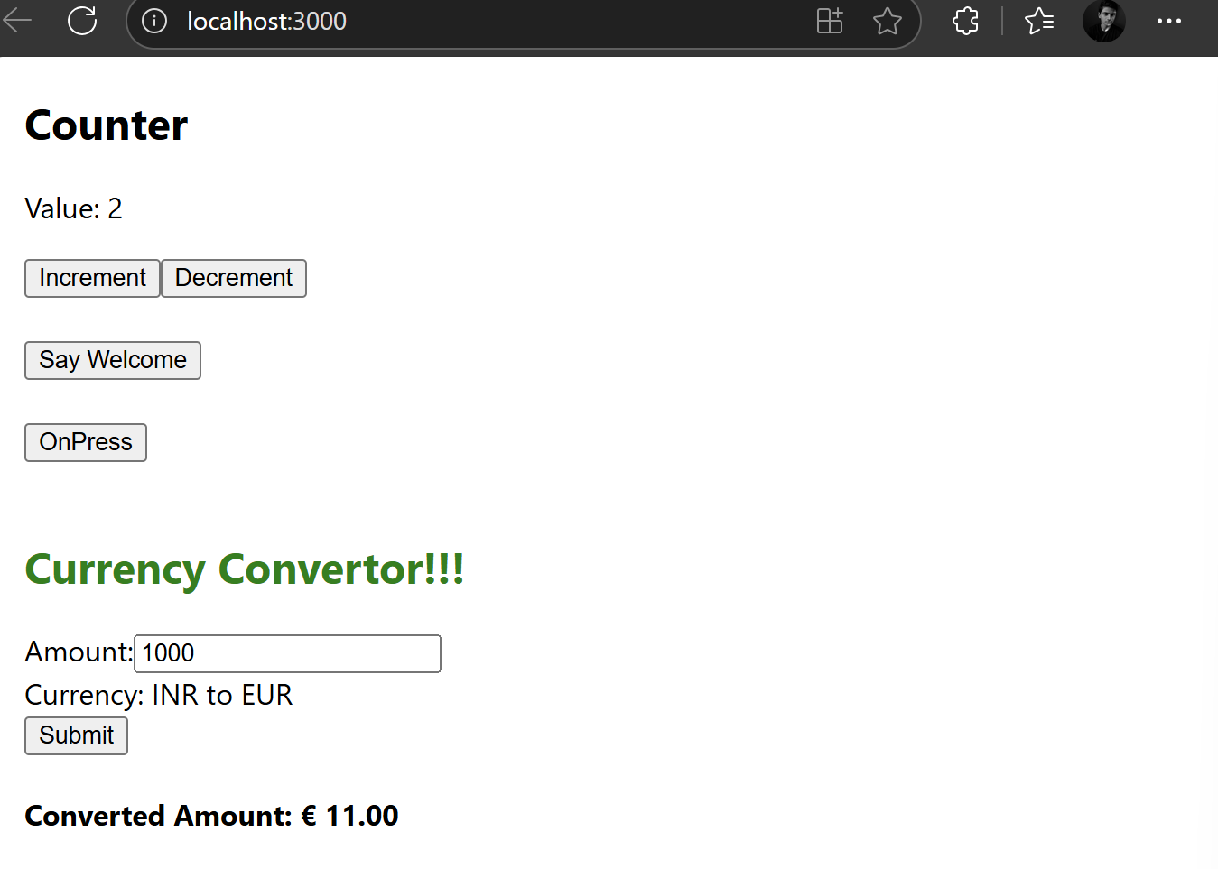 **a).** Layout of the page

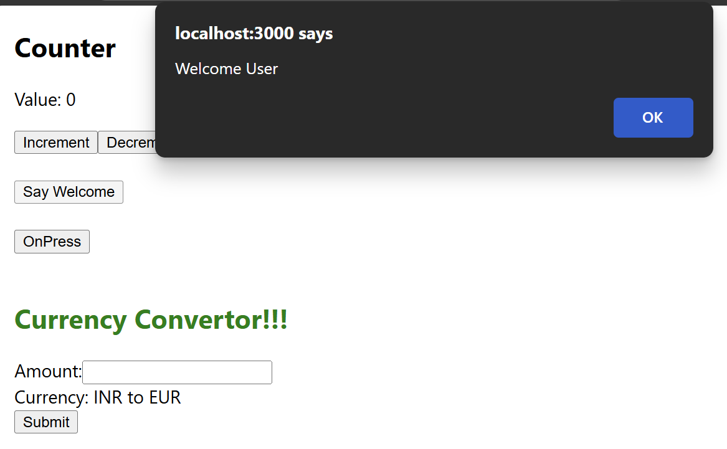 **b).** Welcome feature

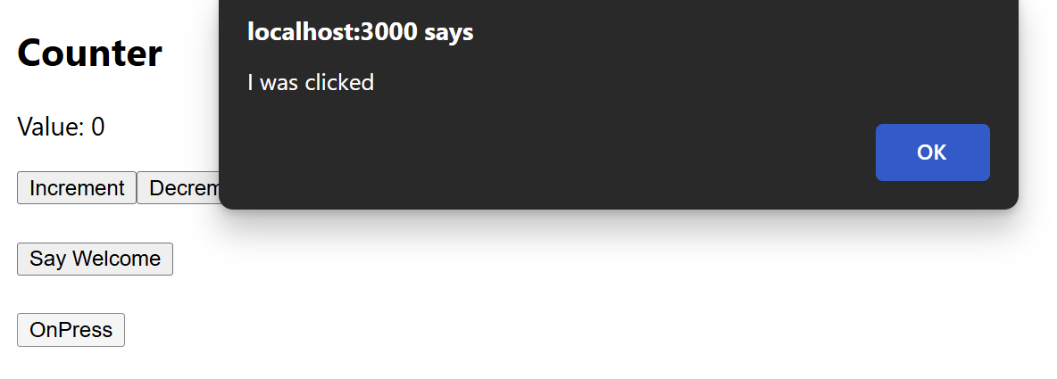 **c).** OnPress button feature

*****************************************************************************************